Hello, my name is Clarissa, I also go by Nikki. To learn more about me I have a background in DECA which led me to my Associates Degree in Business & Administration and I recently became a small business owner with a big vision and an even bigger path. I began my goal to become a Data Scientist in hopes to always have a personal skill that can be applied to multiple mediums and hopefully have something I can do independently with my intent to travel. My current small business requires me to learn algorithms, trends, and explore new possibilities to continue growing as most markets do these days. As technology advances so will my endeavors in Data Science and Entrepreneurship.

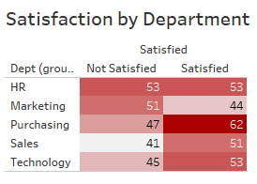

* Satisfaction level determined by each Department
* Marketing has the least amount of “Satisfied” Employees
* Purchasing has the most amount of “Satisfied” Employees
* HR has the same amount of “Satisfied” Employees as “Not Satisfied” Employees

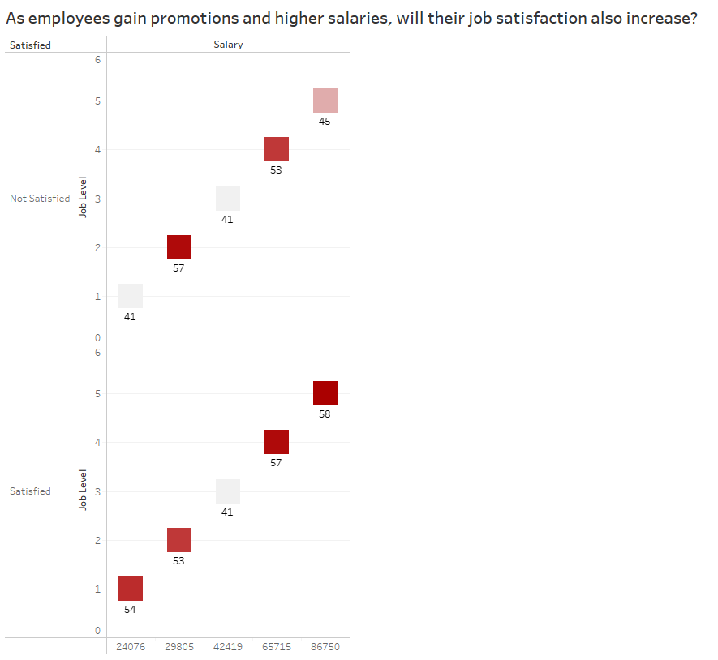

* As employees gain a higher job level their salary increases as well as the amount of “Satisfied” employees
* There seems to be a common ground of 41 “Satisfied” and “Not Satisfied” employees when level 3 is reached

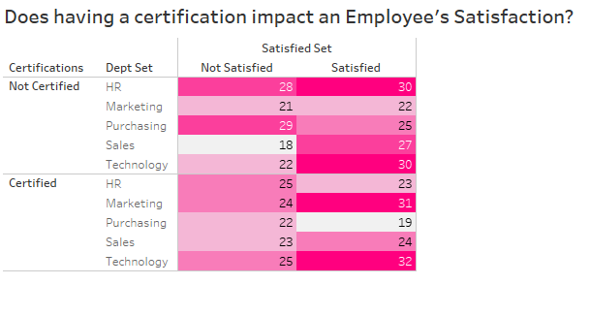

* Having a certification impacts the Technology department “Satisfied” level the most
* Generally, having certifications positively impacts the “Satisfied” count in all departments
* The Purchasing department has the most amount of “Not Satisfied” and “Not Certified” employees
* HR was negatively impacted by having “Certified” employees
* Marketing and Technology had a bigger positive impact from having been “Certified”
* Purchasing had the least amount of “Certified” and “Satisfied” employees